DAP Project Proposal

Team

Name + Year / Degree | Previous Experience / Technical Background | Commitments (Winter + Term 2) | Individual Learning Objective (Clear measurable goals)
He Jinhong  Year 2 IS | - IS1704 Intro to Computational Thinking  - IS112 Data Management  - HTML, CSS, Javascript, Node.js, Supabase | 4 mods | Regarding this project, I would like to extract and analyse trajectory-based features (cornering radius, acceleration smoothness) from reconstructed telemetry to identify performance drivers.  I want to work with my team to engineer at least 5 quantitative features (corner entry speed, acceleration gradient etc.) by the halfway mark of DAP, deepening my understanding of how feature design impacts model performance.
Aadhavan Anna  Year 2 CnL | -IS1704 Python  -IS112 DM (SQL)  -IS113 WAD(PHP, HTML, CSS)  -Basic C Self Taught | Winter: Looking for short Internship  4 Mods | Gain Confidence to start a project and follow to the end  Learn workflow and techniques and be able to implement models on my own.
Shane Chan Year 1 IS | - IS1704 python  - IS114 computing fundamentals  - basic sql  - basic vba | 4 mods | Learn from start to end how the machine learning project goes (scoping project, data, training, evaluation)  Gain better understanding of ml so i can learn on my own

Group Learning Objectives
- Develop the ability to combine multiple imperfect data sources using state estimation techniques to reconstruct missing or uncertain information and enhance data reliability for analysis.
- Learn to derive meaningful and interpretable features from raw data that capture underlying system dynamics, enabling deeper performance analysis and correlation with outcomes of interest.
- Gain the ability to apply, compare, and interpret models of varying complexity to understand how different features contribute to predictive outcomes.

Project Idea

Problem Statement & Motivation

In the world of Formula 1, races are won and lost by milliseconds. While raw telemetry data like speed, lap times, and GPS coordinates are readily available, they don't paint the full picture of a car's performance. A key challenge is that the provided data often lacks the car's precise orientation (velocity vector), making it difficult to accurately reconstruct its trajectory, especially through complex corners. A simple model assuming a straight path will fail dramatically at turns, which are precisely the most critical sections of a track for gaining or losing time.
This project aims to address this gap by leveraging state estimation techniques, specifically the Kalman filter, to fuse incomplete data points like speed and positional coordinates into a coherent and accurate race trajectory. By creating a reliable reconstruction of a car's path, we can extract meaningful geometric features such as cornering radius, racing line characteristics and braking zones that were previously difficult to measure accurately from noisy GPS data.
Ultimately, we would like to identify which trajectory characteristics and driving inputs, for example racing line tightness, apex speed and acceleration smoothness, correlate with faster lap times. We also want to build interpretable machine learning models that not only predict lap performance from these features but also quantify their individual contributions. By understanding precisely which characteristics lead to faster laps and under what conditions, we can provide data-driven insights into optimal race strategy and performance optimisation. Rather than simply predicting lap times, we aim to explain why certain laps are faster, enabling F1 teams to make informed strategic decisions based on quantifiable driving characteristics. While predictive modelling is used to quantify performance outcomes, the primary objective of this project is to understand how reconstructed trajectory characteristics and contextual factors influence lap performance and strategic trade-offs.

Project Milestones

Trajectory Reconstruction & Initial Analysis:
- Perform Exploratory Data Analysis (EDA) on the FastF1 dataset to understand its structure, including the number of data points per car, per race, and data granularity.
- Implement a Kalman filter to process raw telemetry data (position, speed) and generate an accurate, interpolated trajectory for each car.
- Validate the model by analysing the error between predicted and actual positions, with a specific focus on verifying the hypothesis that the largest errors occur during cornering.
Feature Engineering & Performance Correlation:
- From the reconstructed trajectories, engineer new features that quantify driving characteristics. Examples include cornering radius, apex speed, braking/acceleration gradients, and overall line smoothness.
- Analyse the correlation between these engineered features and key performance indicators like sector times and overall lap times.
- Identify the top features that differentiate fast laps from slow ones across different drivers and tracks.
Interpretability and Model Comparison:
Develop and compare models of varying complexity to analyse how trajectory-based features influence lap time.
- Linear Regression: Quantify the direct, interpretable effect of features such as cornering radius and apex speed on lap performance.
- Random Forest: Explore non-linear relationships and identify threshold effects using feature importance rankings and decision-path visualisations.
- Gradient Boosting (e.g., XGBoost): Evaluate whether an advanced ensemble approach improves explanatory power and use SHAP analysis to visualise per-lap feature contributions (which factors made a lap faster or slower).
Ultimately, we aim to produce a data-driven analysis supported by charts and interpretability visuals that clearly explain which features derived from trajectories reconstructed using the Kalman Filter most influence lap time, and under what conditions those features contribute to faster performance.
Validation Strategy:
Kalman Filter Validation:
- Quantitative: Calculate RMSE between filtered and actual positions, targeting <2m average error
- Qualitative: Visual comparison of raw vs. smoothed trajectories, verifying physical plausibility at corners
- Velocity verification: Compare Kalman velocity estimates with telemetry speed data (target <5% difference)
Machine Learning Model Validation:
- Primary Strategy: 80/20 train-test split with stratification by driver to ensure each driver is represented in both sets
- Evaluation Metrics:
  - Mean Absolute Error (MAE): Target <0.5 seconds
  - R² Score: Target >0.85 (explaining 85%+ of lap time variance)
  - Root Mean Squared Error (RMSE): Target <0.7 seconds
- Cross-Validation: 5-fold cross-validation to ensure model stability and avoid overfitting
- Generalisation Testing: Test model performance on laps from drivers or circuits not seen during training
Success Criteria:
- Kalman Filter: Produces smoother, more physically plausible trajectories than raw GPS with <2m reconstruction error
- ML Models: Predict lap times within 0.5 seconds on unseen test data, with Random Forest/XGBoost outperforming baseline Linear Regression

Possible Extensions

Model Enhancement with External Variables:
- Integrate environmental factors (track temperature, air temperature, wind speed, humidity) as additional features in the lap time prediction models to provide a more comprehensive understanding of race conditions.
- Evaluate whether these external variables provide additional explanatory power beyond trajectory-derived and telemetry features alone, helping to account for lap time variations caused by changing weather conditions.
- Develop an enhanced model that combines trajectory characteristics, driver inputs and environmental conditions, offering a holistic explanation of the key factors contributing to a fast F1 lap.
- As a focused extension, tyre compound and tyre life may be incorporated to analyse stint-level lap time degradation, examining how driving smoothness and cornering behaviour interact with tyre wear.

Dataset
FastF1: This is a comprehensive Python package that provides easy access to historical Formula 1 timing, telemetry, and positional data. The dataset includes high-frequency data for each car, such as speed, RPM, throttle, brake application, and gear, alongside its X, Y, and Z coordinates on the track. It also provides session-wide information, including weather reports (air temperature, wind speed, humidity) and official timing data (lap times, sector times).
- Source: https://github.com/theOehrly/Fast-F1

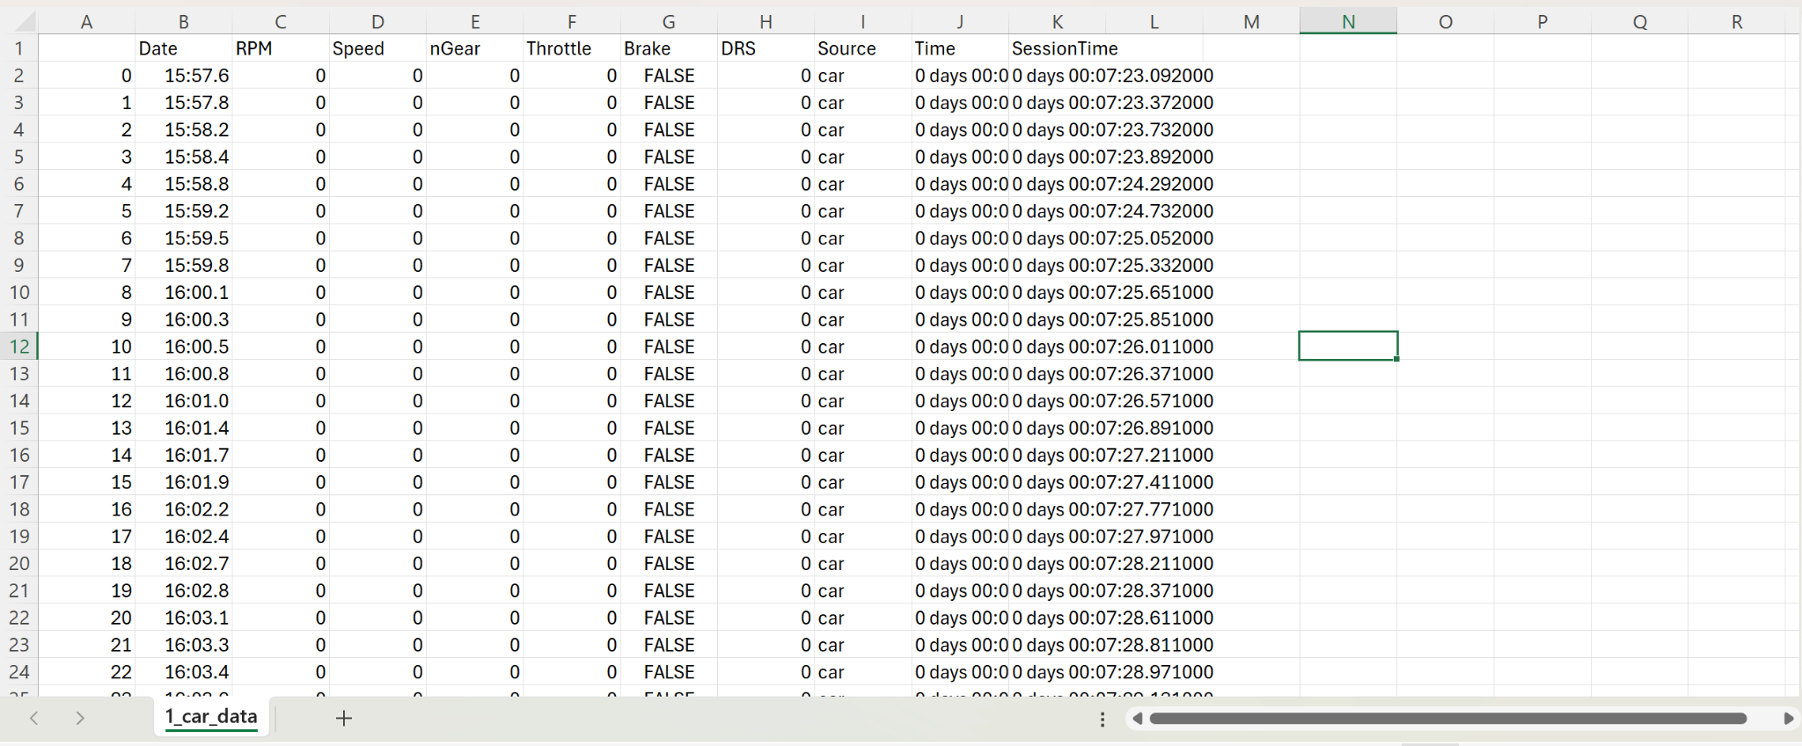
Sample of 1_car_data showing columns such as date, RPM, Speed, nGear etc. The dataset also includes other data such as corners, laps etc.
Data headers in FastF1 organised by data type. (Have not verified all individually but most can)

Lap Data
This is the data you get from a Session.laps object. It provides timing and summary information for each lap completed.
- Time (Timedelta): The session time when the lap officially ended.
- Driver (str): Three-letter driver identifier (e.g., 'VER').
- DriverNumber (str): The driver's car number.
- LapTime (Timedelta): The final recorded time for that lap.
- LapNumber (float): The lap number in the sequence.
- Stint (float): The stint number, which increments with each pit stop for new tires.
- PitOutTime (Timedelta): Session time when the car exited the pit lane.
- PitInTime (Timedelta): Session time when the car entered the pit lane.
- Sector1Time, Sector2Time, Sector3Time (Timedelta): The times for each of the three sectors.
- Sector1SessionTime, Sector2SessionTime, Sector3SessionTime (Timedelta): The session time when each respective sector time was set.
- SpeedI1, SpeedI2 (float): Speed trap data for the first and second intermediate points on the track.
- SpeedFL (float): Speed recorded at the finishing line speed trap.
- SpeedST (float): Speed at the main speed trap, typically on the longest straight.
- IsPersonalBest (bool): True if the lap was the driver's personal best of the session.
- Compound (str): The tire compound used (e.g., 'SOFT', 'MEDIUM', 'HARD').
- TyreLife (float): The number of laps driven on that set of tires.
- FreshTyre (bool): True if the tires were new at the start of the stint.
- Team (str): The constructor/team name.
- LapStartTime (Timedelta): The session time when the lap began.
- LapStartDate (Timestamp): The absolute real-world timestamp when the lap started.
- TrackStatus (str): A code representing the track status during the lap (e.g., '1' for Green, '2' for Yellow, '4' for Safety Car).
- Position (float): The driver's race position at the end of the lap.
- Deleted (bool): True if the lap time was deleted by the stewards.
- DeletedReason (str): Explanation for why the lap was deleted.
- IsAccurate (bool): True if the lap has accurate start and end times from the data source.

Telemetry Data
This is the detailed, time-series data from the car's sensors throughout a lap, accessed via methods like lap.get_car_data(). You can always check available channels for a given lap with lap.get_car_data().columns.
- Time (Timedelta): Timestamps for each data point within the lap.
- SessionTime (Timedelta): The elapsed time in the session.
- Distance (float): Distance traveled along the lap in meters.
- Speed (int): The car's speed in km/h.
- RPM (int): Engine revolutions per minute.
- Throttle (int): The percentage of throttle application (0-100).
- Brake (bool): A boolean value indicating if the brakes are being applied (True/False).
- nGear (int): The current gear selected (0 for neutral, 1-8).
- DRS (int): The Drag Reduction System status. Values like 10, 12, or 14 indicate different enabled states.
- DriverAhead (str): The three-letter code for the driver directly ahead on track.
- DistanceToDriverAhead (float): The distance in meters to the car in front.

Session & Metadata
This is contextual data about the entire event, available through various attributes of the main Session object.
- Session Info: The name of the session ('FP1', 'Qualifying', 'Race'), event name, date, and location.
- Results: DataFrames containing grid positions, finishing positions, points scored, and finishing status (e.g., 'Finished', 'DNF').
- Weather Data: A DataFrame typically containing TrackTemp, AirTemp, Humidity, Pressure, WindSpeed, and WindDirection.
- Race Control Messages: A log of official messages, including flag notifications and steward decisions.
- Driver List: Information about all drivers participating in the session, including their full names, team, and number.

Initial EDA

To validate the feasibility of using Formula 1 telemetry data for trajectory reconstruction and performance modeling, our team conducted an initial exploratory data analysis (EDA) using the FastF1 Python library. We used FastF1 to connect to the official Formula 1 telemetry API, which provides high-resolution data for each driver’s lap, including X–Y positional coordinates, speed, throttle, brake, and gear, as mentioned above.

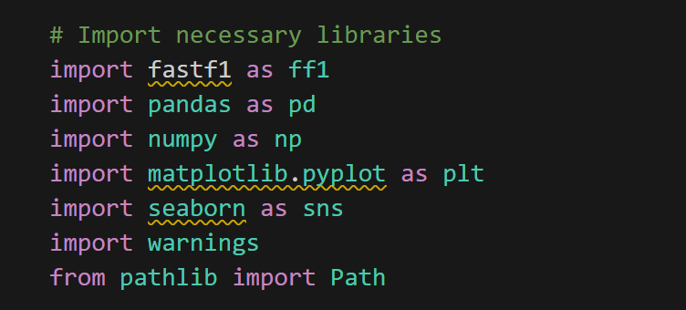

For our initial comparison, we used George Russell for the Singapore Grand Prix 2025 qualifying session and extracted their fastest laps with fields such as spatial coordinates, speed, mechanical inputs such as throttle, brake and gear, and distance. We then plotted each driver’s trajectory via matplotlib and it was consistent with the Marina Bay track layout, verifying accurate positional tracking.

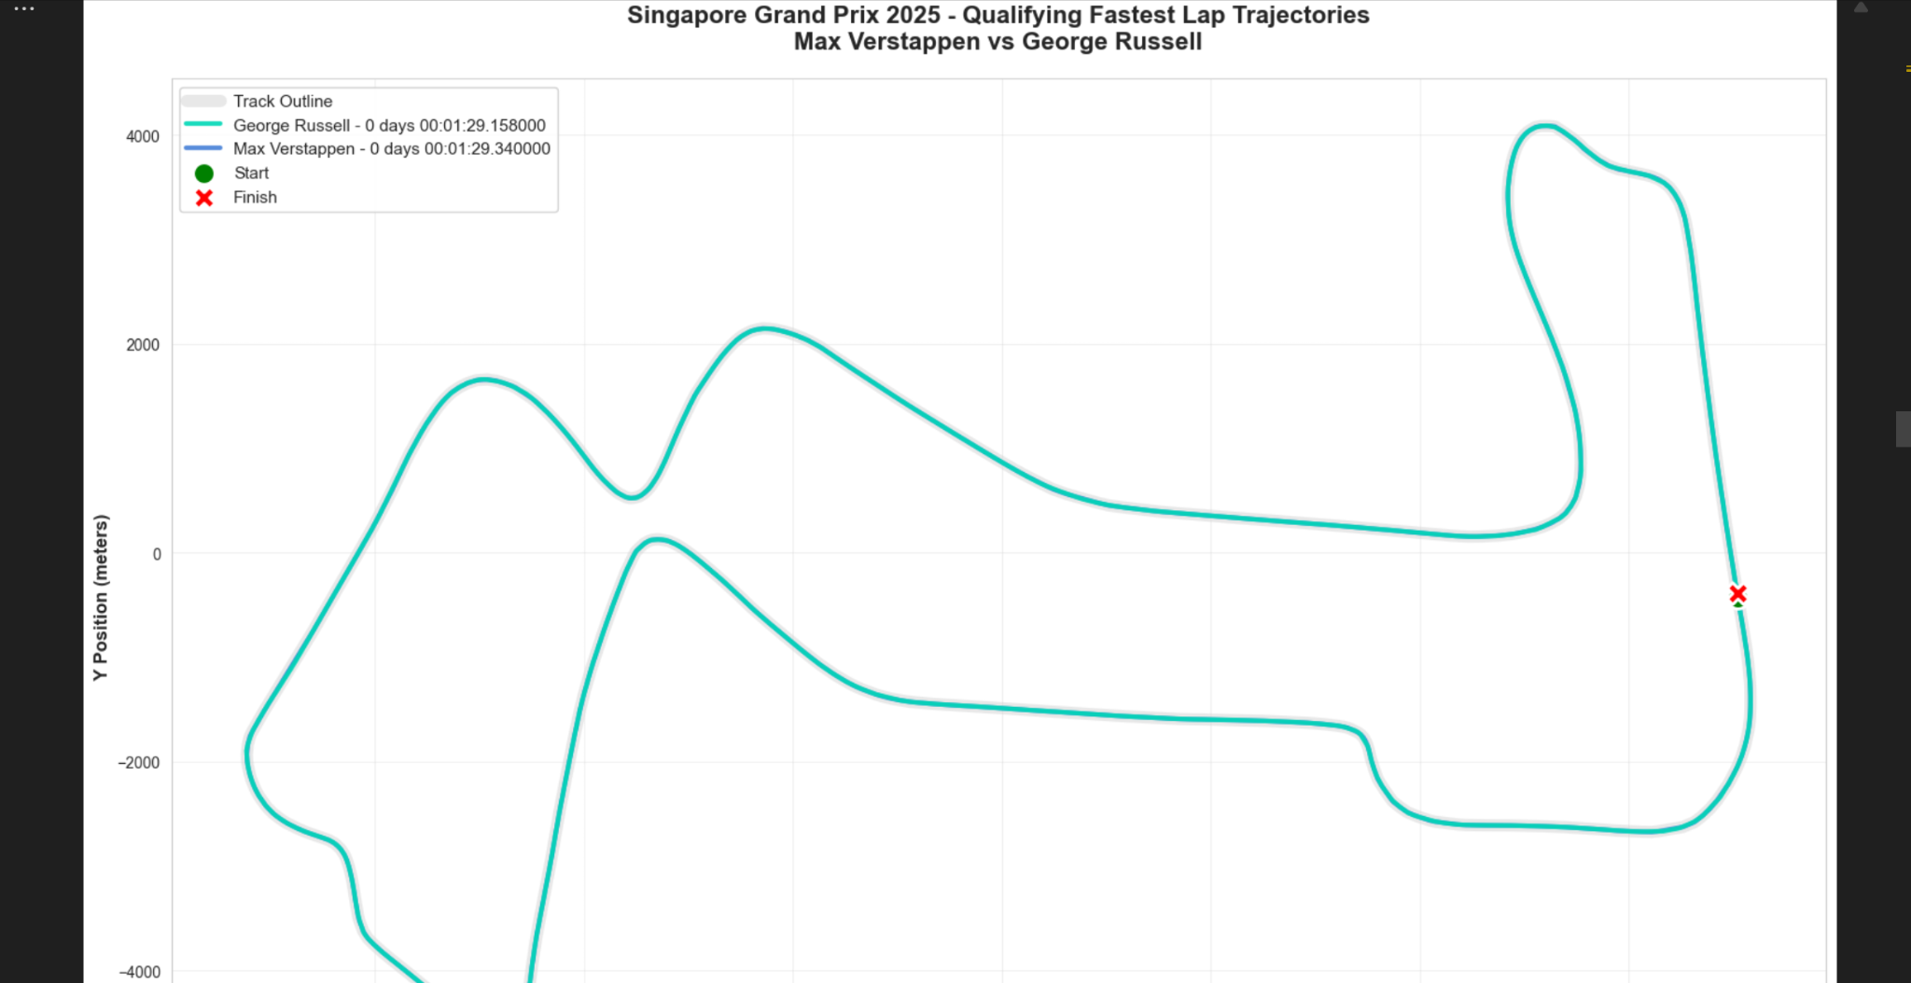
Graph plotted based on the spatial coordinates of the racecar drivers

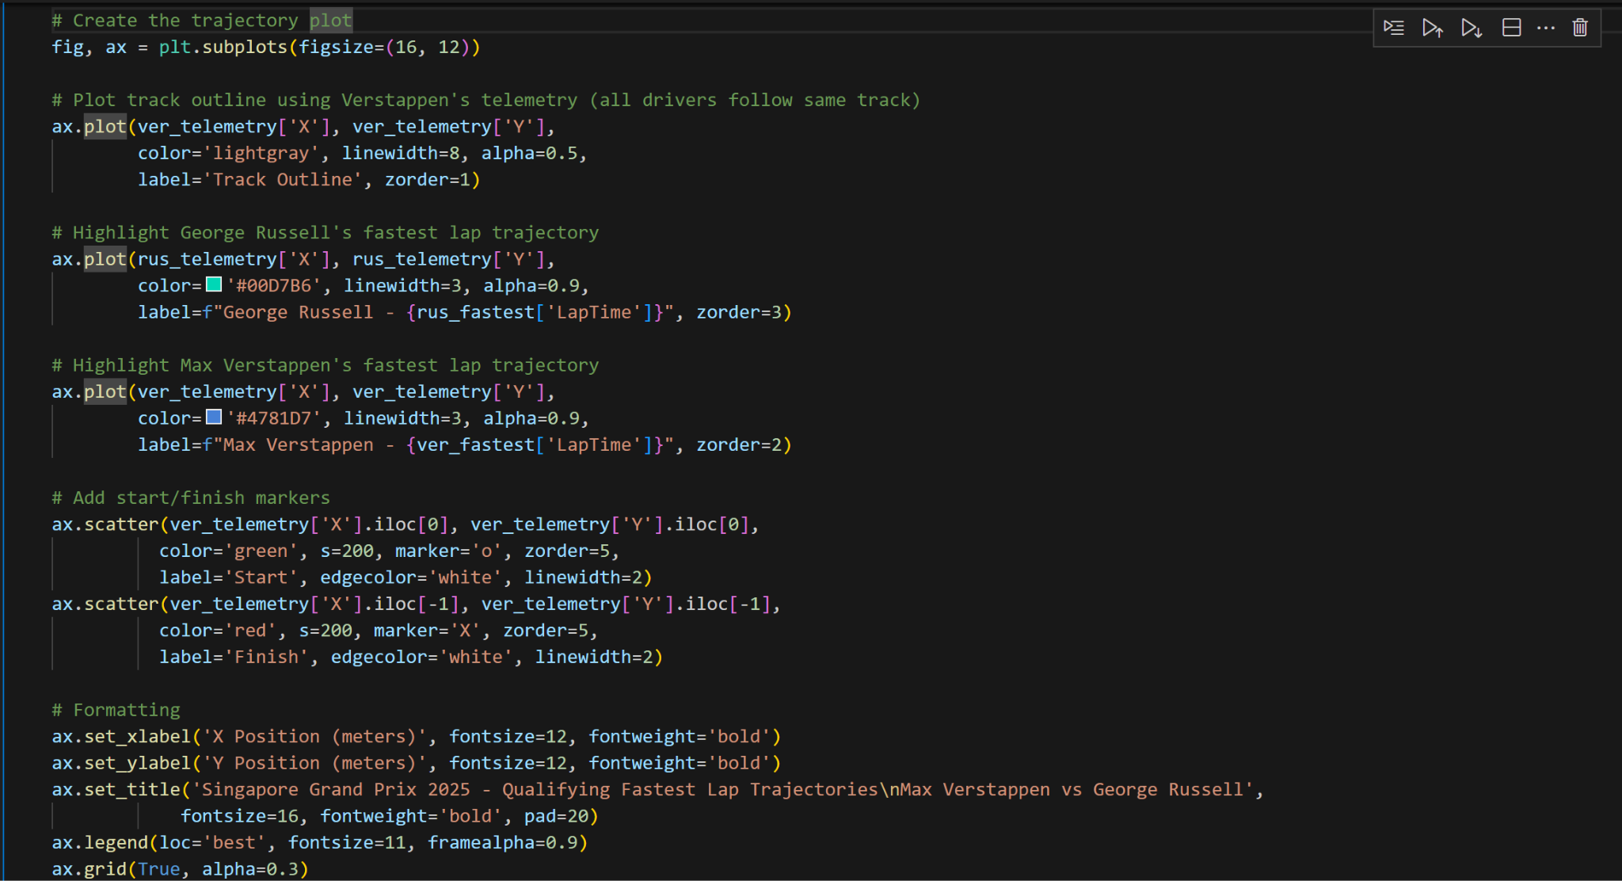
Code utilised to obtain the graph

This confirms that the FastF1 telemetry dataset is fully accessible and reliable for modelling car trajectories. The analysis validated data extraction, positional accuracy and correlation between physical parameters and is ready to implement a Kalman Filter to interpolate the car’s velocity vectors and identify cornering behaviours.

In addition, we have also performed simple analysis to show why simple trajectory models are insufficient for F1 race cars, justifying the need for advanced state estimation models like Kalman Filters.

Google Colab link: JAS F1_EDA.ipynb

Project Plan

Week of | Main Goals | Team Notes  (Team availability etc.) | DAP Notes
10/6/2025 | Proposal Submission |  | Open Office Hours
10/13/2025 | - End of Term Projects,  - Finals Prep  - Begin on reading up on Machine Learning i.e Kalman filter  - Familiarising with the FastF1 Dataset  - Interpreting the data and attempt to clean the data |  | DAP Group Interviews begin
10/20/2025
10/27/2025 |  |  | Finalized offer to DAP no later than this week
11/3/2025
11/10/2025 |  |  | DAP Mini-Workshop (Tentative)
11/17/2025
11/24/2025 |  | Finals
12/1/2025 |  | Finals
12/8/2025 |  |  | DAP Mini-Workshop (Tentative)
12/15/2025
12/22/2025 | Milestone #1: Kalman Filter implementation on the F1 dataset
12/29/2025
1/5/2026 |  |  | DAP Co-Learning Session #0 - TBC
1/12/2026 |  | Term 2 Commences | DAP Co-Learning Session 1
1/19/2026 | Milestone #2: Feature Extraction  - Calculate cornering radius at each point  - Identify apex points for each corner  - Calculate corner entry/ exit speeds  - Calculate deceleration rates (braking intensity from velocity changes) |  | DAP Co-Learning Session 2
1/26/2026 | - Calculate acceleration smoothness  - Engineer “Distance to next corner” feature | Target: Achieve at least 5 quantitative features | DAP Co-Learning Session 3  DAP Project Interim Updates #1-3
2/2/2026 |  |  | DAP Co-Learning Session 4  DAP Project Interim Updates #4-6
2/9/2026 |  |  | DAP Co-Learning Session 5  DAP Project Interim Updates #7-9
2/16/2026 | Milestone #3: Correlation Analysis  - Correlation matrix: features vs lap time  - Features ranking: identify the top 3-5 most important features  - Compare features among F1 drivers  - Analyse correlations between trajectory-derived features and lap time, and evaluate how these relationships vary across drivers, tracks and stints. This will inform feature selection for the ML models in Milestone #4 |  | Lunar New Year
2/23/2026 |  |  | DAP Co-Learning Session 6  DAP Project Interim Updates #10-12
3/2/2026 | Milestone #4: Implement interpretable ML models to evaluate the contribution of trajectory and contextual features to lap performance.  - Implement Linear Regression as baseline  - Implement Random Forest and XGBoost  - Perform 5-fold cross-validation  - Evaluate models using MAE, RMSE, and R² on test set  ● Generate SHAP values for model interpretability  ● Select best-performing model based on validation metrics | Recess Week | DAP Hack Day  DAP Co-Learning - Bonus Topics - TBC
3/9/2026 | Post-Hackday clean-ups of project demo / deployment |  | DAP Co-Learning Session 7  DAP Project Interim Updates #13-15
3/16/2026 | Buffer Week |  | DAP Co-Learning Session 8
3/23/2026 | Buffer Week |  | DAP Co-Learning Session 9
3/30/2026 | Buffer Week |  | DAP Project Showcase Presentation

